First Author Name Surname, Affiliation
Second Author Name Surname, Affiliation
Third Author Name Surname, Affiliation
Table I
Table Name
Column 1 | Column 2 | Column 3 ª
xx1 | yyy1 | zzz1
xxx2 | yy2 | zzz2
xxx3 | yyy3 | zz3
xxx4 | yy4 | zzzzz4
xxx5 | yyyyy5 | zz5
ª[Footnote Text] Content.

TABLE I
[Table Title] Table Name
Column 1 | Column 2 | Column 3 ª
xx1 | yyy1 | zzz1
xxx2 | yy2 | zzz2
xxx3 | yyy3 | zz3
xxx4 | yy4 | zzzzz4
xxx5 | yyyyy5 | zz5
ª[Footnote Text] Content.

Preparation of Papers for GIET University Journal-Engineering, Science, Agriculture and Management

Abstract—This instruction gives you guidelines for preparing papers for GIET University Journal. An abstract should not normally exceed 100 words.

Keywords—technology, electronics, optoelectronics, photonics, telecommunications, signals. circuits, systems, applications

Introduction
T
HE submitted manuscript should be prepared strictly according to the guidelines presented in this paper. Use this document as a template if you are using Microsoft Word 2003 or higher. The Manuscript length should contain 6 pages at least. It should be in a two-column format. In general, a full manuscript consists of "Introduction", "Objectives", "Methods", "Results", "Discussion" and "Conclusions". English is treated as the only written language throughout the text.
We accept papers prepared in MS Word (2003 or higher) or LaTeX text editors. The text of the manuscript should be typed on the standard A4 paper, with the 19 mm margins at top and 27 mm at bottom, and 13 mm margins at left and right. The paper should be typed single-spaced using Times New Roman font. Text should be 10-pt., the title 16-pt., the abstract 9 pt, figure captions and references should be 8-pt, header 7 pt.
The title of the paper is to be typed in lower case. Please use footnote for authors’ affiliations and give also e-mail addresses of authors.
The abstract should concisely state the purpose of the investigation and summarize the important conclusions. It should be a single paragraph of generally no more than 200 words.
Immediately after the abstract, 3-8 words or short phrases should be included for online searching (e.g., Keywords Table, Figure, Manuscript Format)
Equations should be placed within the text (1). They should be centred and numbered successively with Arabic numerals (minor non-referenced expressions might be not numbered). The equation’s number should be positioned in parentheses right justified at the line of the equation:
(1)
Variables should be set in italics while functions, standard quantities, constants, and numerals should be set in romans. Vectors and matrices should be indicated by bold romans or bold italics, e.g. a or a for vectors and A or A for matrices.

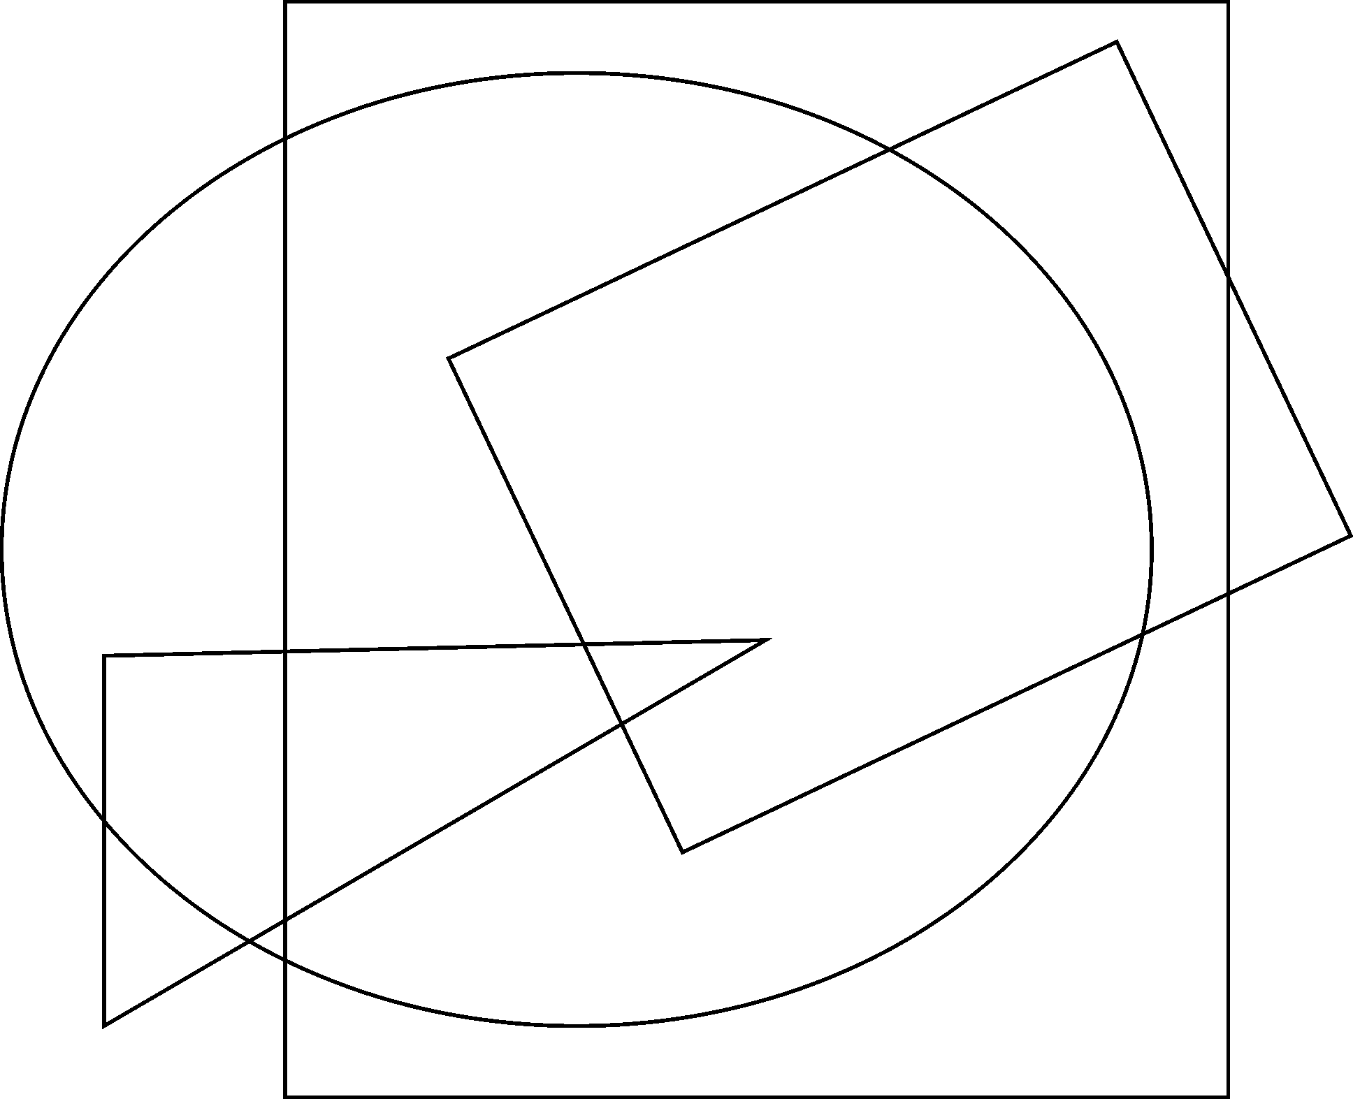
Fig. 1. Example of figure 1. Explain the significance of the figure in the caption.
All figures and tables should be numbered and always referred to in the text (e.g., Fig. 1 and Table 1). Figures should be clear and be finished high-quality artworks. Lettering should be large enough to be readily legible. Image quality is very important to how your graphics will reproduce. If your graphic looks low in quality on your printer or monitor, please keep in mind that cannot improve the quality after submission.
Refer to equations by their numbers in parentheses or write out the word equation (do not abbreviate) and the number. Figures should be referred to in the abbreviated form Fig. 2 (but use Figure 2 when starting a sentence) while referring to table requires the form Table, e.g. Table II.
Fig. 2. Category 1 and category 2
References in the text should be numbered sequentially in the order in which they appear. Place their numbers in square brackets, for example [1]. Some sample references in a bibliography will follow in the last section of this paper [1]-[4]. Give all authors’ names; do not use “et al.” unless there are six authors or more. Use a space after authors’ initials. Internet links may be included as references. Internet links should list the author and the full URL (universal resource locator). Use DOI in references.
The table description (table number and table name – see Table II) and the first level headings should be written in capital letters.

[Heading 1] Figures, Tables and Others

[Heading 2] Figures
Figures must be created at a minimum resolution of 300 dpi to avoid bad printing quality. For fuzzy or jagged figures, authors are required to replace it or send the original figure file to us for reproduction. Figures Numbering & Citation.

(a)

(b)
(c)

Fig.3. Example of figure 2. Pulse generator circuits (a) clock chopper (b) Naffziger (c) NEC RISC processor
Figures must be created at a minimum resolution of 300 dpi to avoid bad printing quality. For fuzzy or jagged figures, authors are required to replace it or send the original figure file to us for reproduction. Figures Numbering & Citation.
All figures are to be sequentially numbered with Arabic numerals. Figures should always be cited in consecutive numerical order. (Figure 3) Parts in a figure can be identified by a, b, c etc. and cited as Fig. 3a, Fig. 3b, Fig. 3c. For larger figures or tables (8.4cm≤Width≤17cm), you may put them in one column.
- Tables
- Tables Title
Every table must have a unique title placed at the top. Titles should be clear and concise, and they should not be complete sentences.
- Tables Format
Table tools in Microsoft Word are recommended for inserting a table. It’s necessary to avoid tables created with the tab key.
- Tables Numbering & Citation
Tables in the main body of the text should be numbered consecutively according to its appearance in the text. Cite each table in numerical order.
- Equation
- Equation Format
The equation number should be placed in parentheses to the right of the equation. Do not create equations as pictures. Use MathType or insert symbols as normal text.
Equation as normal text:
E=MC²$\sin{α}±\sin{β}=2\sin{\frac{1}{2}\left(α±β\right)}\cos{\frac{1}{2}\left(α∓β\right)}$ (2)
Equation created by MathType:
(3)
- Equation Numbering & Citation
Equations should be numbered consecutively with Arabic numerals to avoid ambiguities, if they will be referred to in text. Citation for an equation should be made by using “(1),” not “Eq. (1)” or “equation (1),” except at the beginning of a sentence: “Equation (1) is…”
- Appendix
An appendix may be included (and is often helpful) in mathematical or computational modeling.
- Reference Style
All sources cited in text must appear in the reference list, and all items in the reference list must be cited in text. With the numerical system, references are arranged in the reference list so that they match the order in which they are cited in the text.
- Reference in-Text Citation Format
References are simply cited with the consistent reference number in square brackets. Do not set references number as superscript number. Do not use “Ref. [3]” or “Reference [3]” except at the beginning of a sentence, e.g. “Reference [3] shows …”

Table II
Table Name

Data | Value | Description
D1 | V1 | Text 1 text text text text text text text text text text text text text text text text text
D2 | V2 | Text 2 text text text text text text text text text text text text text text text text text
D3 | V3 | Text 3 text text text text text text text text text text text text text text text text text

- Reference in-Text Citation Format
References are simply cited with the consistent reference number in square brackets. Do not set references number as superscript number. Do not use “Ref. [3]” or “Reference [3]” except at the beginning of a sentence, e.g. “Reference [3] shows …”
- Single Reference
If the author's name appears in the text, place the reference number immediately after the name.
E.g. A.Author [5] found an innovative scientific phenomenon.
- Multiple References
- Put two or four numbers in numerical order and separate them by commas but no spaces.
E.g.: [2,3]
- Indicate three or more consecutive reference numbers by giving the first and last numbers separated by a hyphen.
E.g.: [3-5]
- List of References
Authors are requested to check all references for completeness, including author names, paper title, publisher, journal heading, Volume, Number., pages for journal citations, Year.

Conclusion
Any comments and suggestions are welcomed so that we can constantly improve this template to satisfy all authors’ research needs.

Acknowledgements
We are very grateful to experts for their appropriate and constructive suggestions to improve this template.

References
- A. Author, “Book style with paper title and editor,” in Title, 1nd ed. vol. 1, C. Editor, Ed. City: Publisher, 2017, pp. 10–50.
- F. Author, H. Author, and I. Author, “Journal style,” Journal, vol. 1, Jan. 1999, pp. 140–151 [Conference, 2016, pp. 300-307].
- F. Author and Z. Author, “Journal style,” Journal, vol. 2, pp. 1–21, Jan. 2015.
- J. A. Author, “Periodical style,” Periodical, vol. 1, no. 1, pp. 30–38, Jan. 1999. DOI: 01XYZ.
- K. A. Author, “Published Conference Proceedings style,” in Proc. Conference, City, 2017, pp. 18–26.
- L. A. Author and M. Author, “Presented Conference Paper style,” presented at Meeting (Conference), City, Jan. 2–7, 2015.
- A. Author, “Conferences,” Publisher, vol. 1, no. 1, pp. 10–18, Feb. 2010. DOI: 08XYZ.
- D. C. Author, “Write this article,” Periodical, vol. 1, no. 1,pp. 5-16, 2017. DOI: 78XYZ.

